**Maria Angel Palacios Sarmiento**

**12/10/2022**

**Laboratory 5: Derivatives in Engineering: Velocity and Acceleration in Free-Fall**

**Abstract:**

By the execution of this project, our goal was to illustrate the application of derivatives with a freefall exercise, understand the relationship between position velocity and exhilaration, also identify the key parameters are freefall and how to calculate derivatives using MATLAB.

In order to prove this, we measured the frequency when the time is set to 1/20 sec, and the sample rate to 20Hz, 40 Hz and 50 Hz. Once , the drop ball game is set, we export the data into Microsoft Excel and begin constructing the table for position velocity and acceleration at a certain time.

The functions used for Excel are represented in the following function and chart:

* 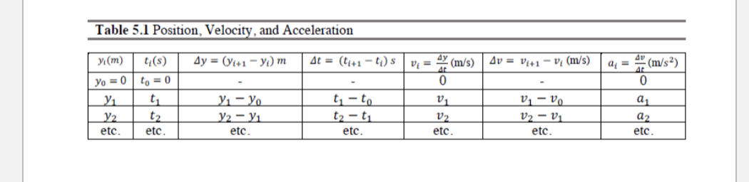**Free fall function:** y(t)= yo - vo*t* +1/2 at2

For the MATLAB code, the time range was set on an interval from 0 to 0.6 with a spacing of 0.1. The acceleration used was 9.8 m/s2 , which represents the gravity value, and since it is a free fall project, the function works according to it.

**5. Questions:**

**a) In free fall, what physical quantity does the acceleration represent?**

The gravity.

**b) What is the mathematical relationship between position, velocity and acceleration?**

That they work in Function of a determined time.